Vishwakarma Institute of Technology
Department of Computer Engineering
A.Y. 2025-26 (Sem I)
Course: Design and Analysis of Algorithms
Tutorial 8: Greedy
- Write Pseudo Code of Prim’s and Kruskal’s Algorithm for finding Minimum Spanning Tree. Derive time complexity of both the algorithms.

- Find the minimum spanning tree for following graphs using Prim’s and Kruskal’s algorithm

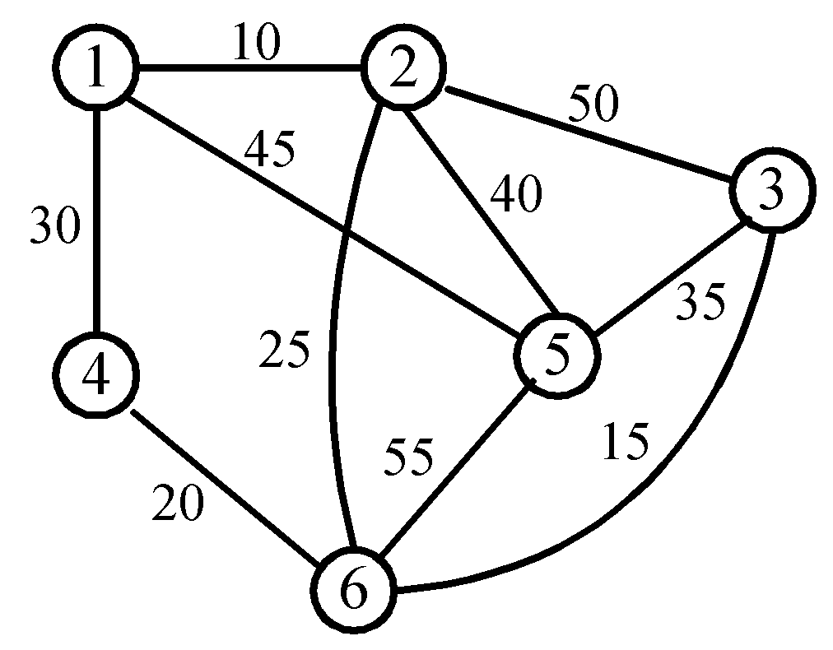 | 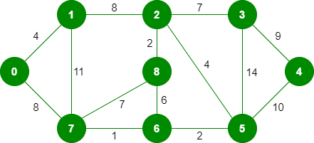

- Conflict free scheduling:
We have a set of requests {1, 2 ..... n}; The ith request corresponds to an interval of time starting at s(i) and finishing at f(i) . We will say that a subset of the requests is compatible if no two of them overlap in time, and our goal is to accept as large a compatible subset as possible. Compatible sets of maximum size will be called optimal. Write an algorithm to find the optimal solution for conflict free scheduling problem.

